Holy Trinity is striving to be a fully inclusive School that serves our local community. Through the love of Jesus Christ, we are preparing our children to be future caring, responsible citizens in a diverse society. Our children will be given every opportunity to grow spiritually, academically and socially to achieve their full potential within a safe, happy, Christian school family.

'Life in all it’s fullness' - John 10 V 10

 | Autumn 1  Colourful Characters | Autumn 2  Changes and Challenges | Spring 1  Brilliant Burnley | Spring 2  Exciting Exploration | Summer 1  Gallant Growth | Summer 2  God’s Wonderful World
Christian Value | Courage | Perseverance | Respect | Joy | Forgiveness | Compassion
English | The Loch Ness Monster  Information text, Children’s Magazine, Narrative: Adventure | Traditional Tales from Another Culture  Traditional Tales, Poetry | The Firework Maker’s Daughter  Issues and Dilemmas, Persuasion | The Last Bear  Narrative Story, Openers, Persuasive Poetry | The Black Hat  Narrative Story | Macavity  Poetry, Newspaper, Recount
Maths | Maths No Problem 4A  Numbers to 10000, Addition and Subtraction within 10000, Multiplication and Division, Graphs, Fractions, Time. |  |  | Maths No Problem 4B  Decimals, Money, Length, Mass, Volume, Area and Perimeter of Figures, Geometry, Position and Movement, Roman Numerals.
Science | Electricity  How does electricity flow around a circuit? | Sound  How does sound travel to our ears? | States of Matter  How do materials change state and can these changes be reversed? | States of Matter  What happens to water when it freezes or evaporates?  OR  How does temperature affect the state of a material? | Living Things and their Habitats  How do plants reproduce and survive in different environment? | Teeth and the Digestive System  What happens to food after you eat it? Describe the journey through the digestive system.  How do animals including humans use their teeth and bodies to survive?
R.E. | Prayer  Where and when do some people of faith pray? | Christmas – Symbolism of Light  Why Is Light an important symbol in World Faiths? | Jesus – The Son of God  Why Do Christians believe Jesus is the Son of God? | Easter  A Story of Betrayal or Trust? | Holy Places  What is the purpose of sacred places or buildings?
History | Boudica  What effects did the Roman Invasion have on Boudics and the Iceni tribe?  What were the consequences of Boudica’s resistance to the Romans? |  | Town Hall  What role did Burnley Town Hall play in local justice? |  |  | Anglo Saxons & Scots  What can we learn about the Anglo Saxons from the discoveries at Sutton Hoo?
Geography |  | Biomes |  | Europe  Burnley’s Twin Town  Vitry-Sur-Seine | Water Cycle and Rivers
Art | Drawing and Exploring Ideas |  |  | Collage: Mondrian |  | Painting:  God’s Big Picture
Design and Technology  Kapow |  | Textiles: Fastenings | Make: Electrical Systems - Torches |  | Cook: Adapting a Recipe
Computing  Purple Mash | 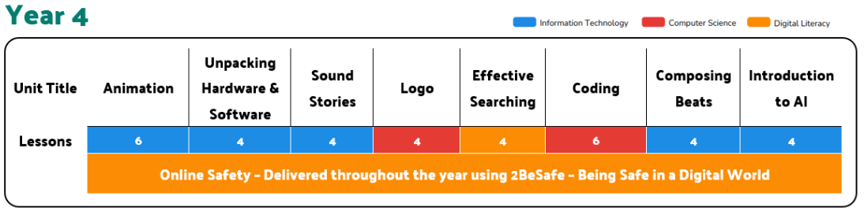
PSHE  SCARF | Valuing Difference | Rights and Respect | Being My Best | Growing and Changing | Me and My Relationships | Keeping Safe
Music  Chranga | Keyboards Lancashire Music Service
P.E. | Invasion Games – Rugby  OAA – Team Work and Problem Solving | Dance – Superheroes  Invasion Games - Rugby | Invasion Games – Netball  Gymnastics | Target Games – Dodgeball  Dance | Net and Wall Games  OAA – Trust and Trails | Striking and Fielding - Rounders
MFL  Spanish  Kapow | Dates in Spanish | Pets | Weather in Spain | In a Spanish Cafe | Spanish Celebrations | The Amazon Rainforest

