Holy Trinity is striving to be a fully inclusive School that serves our local community. Through the love of Jesus Christ, we are preparing our children to be future caring, responsible citizens in a diverse society. Our children will be given every opportunity to grow spiritually, academically and socially to achieve their full potential within a safe, happy, Christian school family.

'Life in all it’s fullness' - John 10 V 10

 | Autumn 1  Colourful Characters | Autumn 2  Changes and Challenges | Spring 1  Brilliant Burnley | Spring 2  Exciting Exploration | Summer 1  Gallant Growth | Summer 2  God’s Wonderful World
Christian Value | Courage | Perseverance | Respect | Joy | Forgiveness | Compassion
English | The Way Home for Wolf  Story as a theme – integrated unit | Traditional Tales with a Twist  Traditional Tales/Fairy Tales with a twist | Amazing Birds  The Owl who was Afraid of the Dark  Non-Chronological Reports, Narrative – story as a theme, persuasion |  | Aladdin  Story as a theme
Maths | Maths No Problem 2A  Numbers to 100, Addition and Subtraction, Multiplications of 2, 5 and 10, Multiplication and Division of 2, 5 and 10, Length, Mass, Temperature, Pictograms. |  |  | Maths No Problem 2B  Word Problems, Money, 2D Shapes, 3D Shapes, Fractions,  Time and Volume.
Science | Animals – Survival/Growth  How do animals grow and change? | Uses of Materials  How can we change a material and what would we use it for? | Living Things and their Habitats including Food Chains  Why do animals live in different habitats? | Seasonal Changes  How do the length of the day and the temperature change between winter and summer? | Plants and Growth  How do plants grow and change over time? | Health  What do humans need to stay healthy?
R.E. | The Bible  Why Are Sacred Texts/Holy Books So Important To People of Faith? | Christmas  Why Do Christians Believe The Birth of Jesus Was Such Good News? | Jesus, friend to everyone  Why Did Jesus Welcome Everyone? | Easter  How Do Symbols Help People To Understand The Easter Story? | The Church  Why Are Holy Buildings and Places Important To People of Faith? | Ascension and Pentecost  What Do Christians Believe Happened at Ascension and Pentecost?
History | Florence Nightingale  How/why did Florence Nightingale improve health care during the Crimean War? |  | World War 1: Remembrance/Alfred Victor-Smith  What were the consequences of Alfred Victor-Smith’s heroic actions? |  |  | Great Fire of London  What features of London, a long time ago, might have helped cause the Great Fire of London?
Geography | Alice Springs and the 7 Continents  Why do oceans matters? |  |  | Improving the sustainability of our school  How can we improve the school grounds? |  | Hot & Cold  What is it like to live in hot and cold places of the world?  What is like to live on the Equator?
Art | Drawing and Exploring Ideas |  |  | Painting:  Jackson Pollock |  | 3D:  God’s Big Picture
Design and Technology  Kapow |  | Textiles:  Money Pouches | Make:  Mechanisms  Wheels and Axles |  | Cook: A Balanced Diet
Computing  Purple Mash | 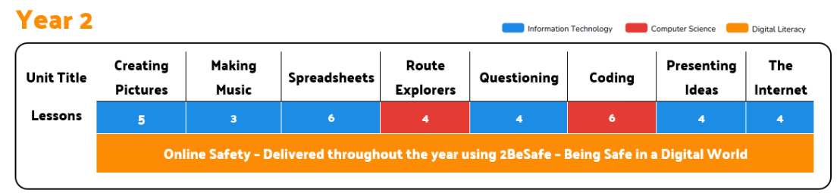
PSHE  SCARF | Valuing Difference | Rights and Respect | Being My Best | Growing and Changing | Me and My Relationships | Keeping Safe
Music  Chranga | Hands, Feet, Heart | Ho, Ho, Ho | I Wanna Play in a Band | Zootime | Friendship Song | Reflect, Rewind and Replay
P.E. | FMS: Overarm Throw  FMS: Underarm Throw | FMS: Catching and Bouncing a Ball  Gymnastics | FMS: Rolling a Ball  Dance – Once Upon a Giant | Games – Piggy in the Middle  Athletics | Games – Striking and Fielding  Games – Net and Wall | OAA – Great Outdoors  FMS – End of KS1 Assessment

