Holy Trinity is striving to be a fully inclusive School that serves our local community. Through the love of Jesus Christ, we are preparing our children to be future caring, responsible citizens in a diverse society. Our children will be given every opportunity to grow spiritually, academically and socially to achieve their full potential within a safe, happy, Christian school family.

'Life in all it’s fullness' - John 10 V 10

 | Autumn 1  Colourful Characters | Autumn 2  Changes and Challenges | Spring 1  Brilliant Burnley | Spring 2  Exciting Exploration | Summer 1  Gallant Growth | Summer 2  God’s Wonderful World
Christian Value | Courage | Perseverance | Respect | Joy | Forgiveness | Compassion
English | Harry the Happy Mouse  Nursery Rhyme/Poem with a structure, story with a familiar setting, information texts | Supertato  Story as a theme, poem as a theme, instructions, nativity performance | The Highway Rat  Story as a theme, poem as a theme, information texts | Peter Rabbit  Information texts, classic stories, traditional rhymes | The Ugly Five  Small poem, Knowledge and Information Text | How to Train a Train  Non-fiction texts, information, instructions and persuasion, stories with familiar settings, traditional songs and rhymes
Maths | Maths No Problem 1A  Numbers to 10, Number Bond, Addition within 10, Subtraction within 10, Positions, Numbers to 20, Addition and Subtraction within 20, Shapes and Patterns, Height and Length. |  |  | Maths No Problem 1B  Numbers to 40, Addition and Subtraction Word Problems, Division, Fractions, Numbers to 100, Time, Money, Volume and Capacity, Mass and Space.
Science | Animals – Other Animals  What are animals and humans like and what do they need to survive? | Everyday Materials  What are objects made from and why are different materials used? | Seasonal Changes  What changes happen from Summer to Autumn? | Animals- Humans  Which part of the body helps you see, hear, smell, taste, and touch? | Plants: Common Names  Do plant all look the same? | Seasonal Changes  What are the four seasons and what is the weather usually like in each one?
R.E. | Harvest  Why is saying thank you so important? | Creation  What do people believe about how the world began?  Christmas  Why do many people give and receive gifts at Christmas? | Jesus  What made Jesus special? | Easter  Why do Christians believe Easter is a new beginning? | Baptism  How do families welcome new babies?
History | Ella Fitzgerald  How did Ella help people who were less fortunate? |  | Towneley Hall  How has Towneley Hall changed over the last 120 years? |  |  | Toys: Changes in Living Memory  How are the toys you play with similar/different to toys your parents and grandparents played with?
Geography |  | Local Area  What is Burnley like? |  | Fieldwork: School  What is your favourite place in the school grounds? Does it change throughout the year? | The United Kingdom  What is the United Kingdom?
Art | Drawing and Exploring Ideas |  |  | Printing:  Monet |  | Textiles: God’s Big Picture
Design and Technology  Kapow |  | Textiles: Puppets | Make: Structures  Windmills |  | Cook: Fruits and Vegetables
Computing  Purple Mash | 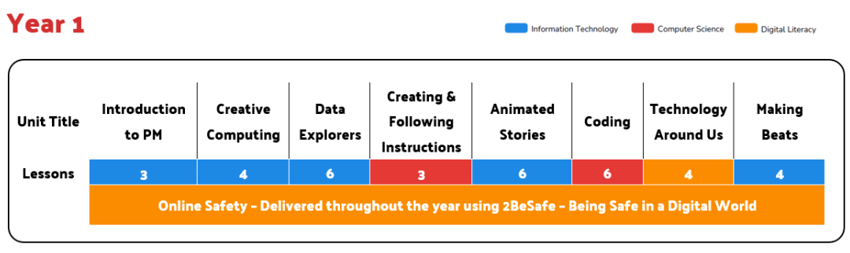
PSHE  SCARF | Valuing Difference | Rights and Respect | Being My Best | Growing and Changing | Me and My Relationships | Keeping Safe
Music  Chranga | Hey You! | Rhythm in the way we walk and Banana Rap | I Wanna Play in a Band | Round and Round | Your Imagination | Reflect, Rewind and Replay
P.E. | Year 1 Baseline: Lost and Found  Y1 FMS: Underarm Throw | FMS: Supertato  Y1 FMS: Overarm Throw | KS1 FMS: Kicking  Gymnastics | Athletics  Y1 FMS: Catching and Bouncing a Ball | FMA: Rolling a Ball  FMS: Tri Golf | OAA: The Great Outdoors  Dance: Toy Story

