Holy Trinity is striving to be a fully inclusive School that serves our local community. Through the love of Jesus Christ, we are preparing our children to be future caring, responsible citizens in a diverse society. Our children will be given every opportunity to grow spiritually, academically and socially to achieve their full potential within a safe, happy, Christian school family.

'Life in all it’s fullness' - John 10 V 10

 | Autumn 1  Colourful Characters | Autumn 2  Changes and Challenges | Spring 1  Brilliant Burnley | Spring 2  Exciting Exploration | Summer 1  Gallant Growth | Summer 2  God’s Wonderful World
Christian Value | Courage | Perseverance | Respect | Joy | Forgiveness | Compassion
English | Fiction  The Colour Monster 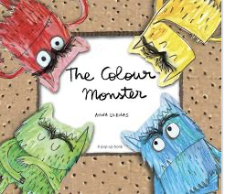  Non- Fiction  My big book of feelings.  Poetry  Feelings Poems | Fiction  The Best Birthday Present Ever 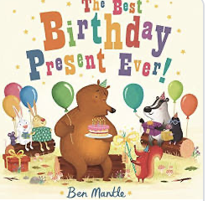  Traditional Tale  Goldilocks and the Three Bear  Poetry  Fun Birthday | Traditional Tale The Little Red Hen  Non-Fiction – People Who Help Us | 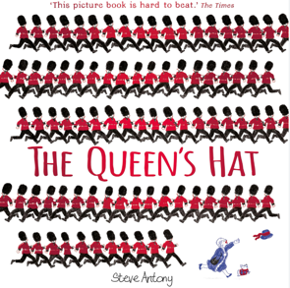  Fiction – The Queen’s Hat  Non-Fiction – A Walk in London | Fiction – The Very Hungry Caterpillar  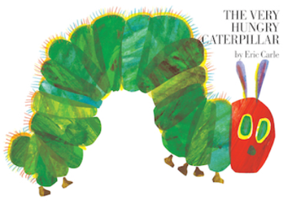  Non-Fiction –Mad about Minibeasts  Traditional Tale – Jack and the Beanstalk | Fiction – What the Ladybird Heard at the Seaside  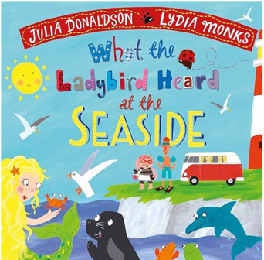  Non-Fiction – Creatures of the Sea  Traditional Tale/Poetry/Rhyme– Commotion in the Ocean
Maths | Matching, Sorting, Comparing and Ordering, AB Patterns, Counting, Time, Composition of Numbers up to 5, 2D Shapes, Positional Language |  | Counting, Ordering, Addition, Comparing and Ordering, Patterns, Measuring Lengths and Heights, Capacity, 2D Shapes, 3D Shapes |  | Counting On to Add, Counting Forwards and Backwards, Counting to 20, Doubling, Halving and Sharing, Odds and Evens, Mass, Volume and Capacity, Money, Data, All, Word Problems
Science | Animals: Humans  Can you point to and name some parts of your body? What do you use them for? | Materials  What materials can I see and feel and what can they do? | Floating and Sinking  What happens when you put this object in water? Does it float or sink? | Seasonal Changes  What season do you think it is? What clues can you see outside? | Plants and Animals – Growth and Care  How does a plant grow? | Animals excluding Humans  How are animals and people similar and different?
R.E. | I am Special  Why are we all different and special?  Harvest  What do Christians say thank you to God at Harvest Time? | Christmas  How do Christians celebrate Jesus’ birthday? | Stories Jesus Heard  Which stories did Jesus hear when he was a child?  Stories Jesus Told  Why did Jesus tell stories? | Easter  Why do Christians believe that Easter is all about love? | Special Places  Where do some people go to worship God? | Prayer  How do some people of faith talk to God?
History | Family History  Who is special to me? |  | Brilliant Burnley: The History of our School  How has our school changed over time?  Who helps keep things fair and just? |  |  | Our Home Town  What the key features of our civilisation? How long have I lived here? Why do people we know move to Burnley?
Geography |  |  |  | School Grounds including Fieldwork around School  Qu: Where is our school and what is it like? | Seasides near and far  Qu: How are seasides different?
Art | Drawing and Exploring Ideas |  |  | Artist Study:  Kandinsky |  | Collage: God’s Big Story
Design and Technology |  | Cook: Soup | Make: Structures:  Boats |  | Textiles: Bookmarks
Computing | Purple Mash  General Computing Skills linked to Mini Mash
PSHE | Valuing Difference | Rights and Respect | Being My Best | Growing and Changing | Me and My Relationships | Keeping Safe

Music

P.E.

