Literacy – Word Reading, Comprehension and Writing |  | Mathematics – Numbers and Numerical Patterns
Read, Write Inc. is a structured and systematic approach to teach literacy skills. It is designed to create fluent readers, confident speakers and willing writers. Throughout the first half term, the children will focus on learning their speed sounds which will later help them with their reading. Special sound books will be sent home to help them practise at home with you.  Reading books will be changed and sent home every Tuesday and Friday.  Please make sure that your child’s book and reading record on in their book bag on these days.  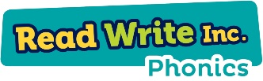 |  | In EYFS, we will be using the Maths No Problem! Foundations scheme.  This year, we will be focusing on early mathematical experiences. Together we will be working on numbers and patterns, exploring early numbers and will look at 2D shapes. Each week we will have a number of the week that we will be learning about.  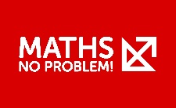
Personal, Social and Emotional Development | Religious Education: I am Special |  | Physical Development
Each child in the class has their own ‘Key Worker’. Each week, the children have ‘Key Worker Time’ to discuss different topics. This will include personal hygiene, safety in the classroom, making friends, and classroom rules.  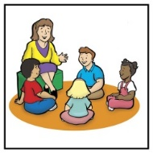 | In R.E. lessons, we will begin by talking about how God makes each one of us different and special. We will then move on to learning about the festival of Harvest and how we celebrate it.  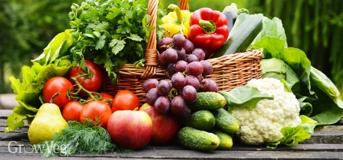 |  | Our P.E. lessons are taught by Mr Little. We have P.E. twice a week on a Thursday and Friday! Please make sure your child has the correct P.E. kit in school. P.E. kits will be sent home each term to be washed.  This term, the children will be taught lots of skills that will help them throughout their journey in school. Multi-skills will include rolling a ball, kicking a ball and balancing.  We recommend that tights are not worn on P.E. days to make it a little easier for the children.  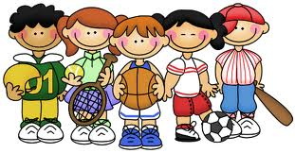
Lead Subjects
History | Art |  | Science
This term we will be exploring the lives of the people around us and their roles in society. We will be talking about key roles people have in society, both in the past and the present.  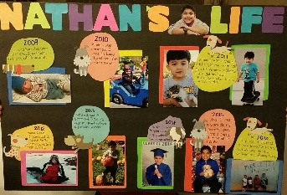 | We will be exploring, naming and mixing a range of colours. We will then explore lines and shapes so that we can create our own self-portrait!  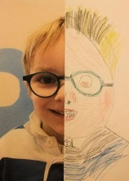 |  | This term, we will be learning about our bodies. We will be learning about how our fingerprints make us unique and how we can keep ourselves fit and healthy.  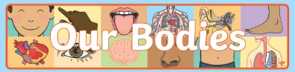
Vocabulary for Autumn 1 - Please take some time to read these key words. This will help your child to understand what we will be learning this term.
numbers  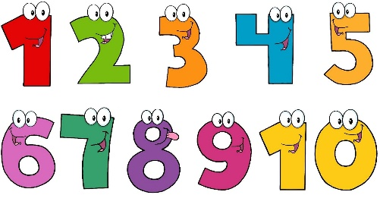 | baby  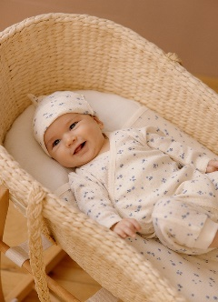 | toddler  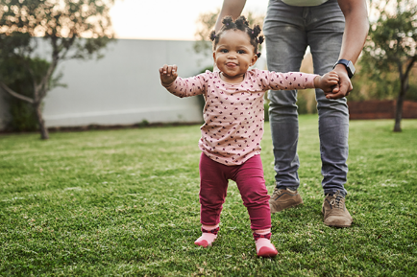
child  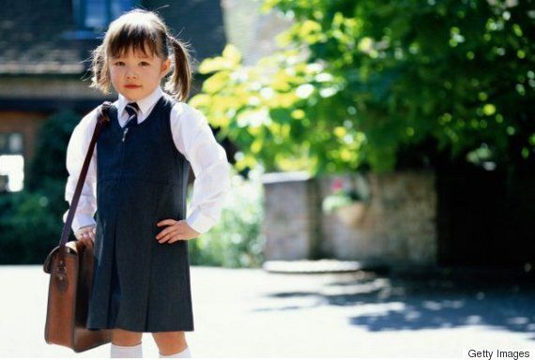 | pencil  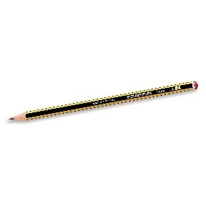 | special  
fingerprint  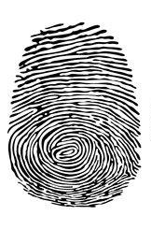 | harvest  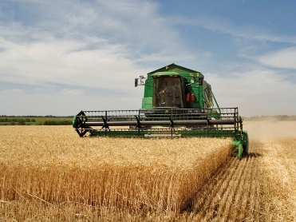 | Complete this sentence and practise saying it:  “My name is…”

