Holy Trinity CE Primary School

Internal Financial Regulations Policy 2026-27

Holy Trinity CE Primary School is striving to be a fully inclusive school that serves our local community. Through the love of Jesus Christ, we are preparing our children to be future caring, responsible citizens in a diverse society. Our children will be given every opportunity to grow spiritually, academically, socially and to achieve their full potential within a safe, happy Christian school family.
‘Life in all is fullness’ - John 10v10

1.0 | ESTABLISHMENT OF BUDGET HEADINGS, MONITORING AND CONTROL PROCEDURES AND EXERCISE OF VIREMENT
1.1 | Each year, on receipt of its funding allocations from the authority / ESFA the Governing Body shall establish appropriate budget headings for the school as a whole under which the budget shall be controlled and determine the initial budget allocation to each heading, the consistent financial reporting (CFR) framework is recommended. Any changes to budget allocations following notification by the Authority of the previous year's surplus / deficit brought forward shall be determined by the Governing Body.
1.2 | The Headteacher may sub-divide the budget determined by the Governors on a departmental or other basis in order to facilitate day-to-day administration and control.
1.3 | The Headteacher is empowered to exercise virement between budget headings approved by the Governors. The maximum virement level being £5,000, or 10% of the budget heading from which resources are being transferred (whichever is the lower in total for any heading during the year). All virements undertaken shall be reported to the Governors at their next meeting. Virement in excess of this figure requires the prior approval of the Governing Body. Increases to expenditure headings offset by increases in anticipated income can be undertaken by the headteacher providing there is evidence to substantiate the additional forecast income, these virements should also be reported to governors.
1.4  1.5 | The Headteacher shall establish suitable arrangements for the control and monitoring of expenditure against budget headings (e.g. SIMS FMS).  The school should have a realistic, sustainable, and flexible financial strategy in place for at least the next 3 years, based on realistic assumptions about future funding, pupil numbers and pressures. In order to set a well-informed and balanced budget each year, schools will need to assess the main influences on the budget on the basis of the best available information and make a forward projection of its budget, Schools should integrate budget setting with their wider plans for school development to ensure that resource allocations match their school’s priorities, including both revenue and capital funds, for at least three years. This is a requirement of SFVS. The Governing Body shall consider financial forecasts, ideally on a termly basis using the best / latest information available, including realistic pupil number projections and can it move quickly to recast the budget if the projections and the reality are materially different
1.6 | To enable the governing body to meet their statutory responsibilities for the financial management of the school and so they can safeguard the large amounts of public money for which they are responsible. It is important that the monitoring reports are produced regularly and shared with the governing body or finance committee at times when action can be taken on them to good effect. DfE and ESFA recommend that governors should receive the monitoring reports and have an opportunity to raise questions or concerns at least 6 times a year. Prompt, accurate and up-to-date financial information should be readily available at the appropriate levels within schools. To achieve this, schools will require clearly defined and properly used channels of reporting to the governing body on a regular basis, which should include the finance committee. The governing body should review the income and expenditure against the budget at a meeting at least 3 times a year. A school that is well managed financially will report different levels of detail, with a suitable narrative explanation to different users. Monitoring reports for the governing body should include numeric information, including about the profiled budget, spend to date and end of year projections. They should also include a brief narrative covering report that highlights what the main variations are, briefly explains the reasons for the variations and suggests what would be appropriate corrective action. In addition, the Headteacher shall inform the Governors immediately if significant overspendings are likely to occur, resulting in the school budget falling into a financial deficit position.
1.7 | The Governing Body shall consider the appropriate level of reserves and balances at the school.
2.0 | CHOICE OF SUPPLIERS AND CONTRACTORS
2.1 | The Governing Body is responsible for ensuring that purchases and contracts entered for the supply of goods and services must comply with Lancashire County Council Procurement Rules for Schools, link below:  Procurement Rules - Lancashire County Council  The table below outlines the Council's requirements in terms of procurement activity dependent on the category and value of the procurement. All values described are inclusive of VAT.  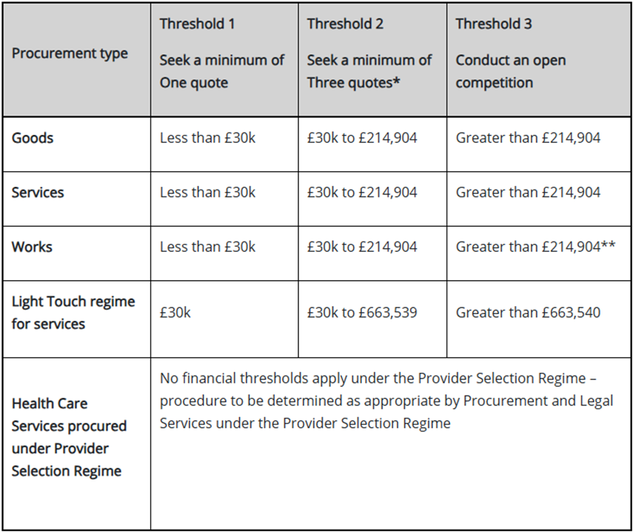
* If a minimum of three legitimate quotes have been demonstrably sought but not received within a reasonable timescale it is considered that the Procurement Rules have been complied with.

** If seeking open competition is not feasible in the circumstances, where the contract value is below the works UK Procurement Threshold in the Procurement Legislation, a three quote process may be undertaken, provided that the reasons for not undertaking an open competition are reported to the Governing Body and recorded in the minutes of the meeting

2.2 | The Headteacher shall maintain a record and copies of all quotes and tenders received and retain for audit inspection.
2.3 | The governing body and school staff have a responsibility to avoid any conflict between their business and personal interests and affairs and those of the school.  Governing bodies/boards of maintained schools are legally required to maintain a register of business interest, which lists for each member, including the headteacher, any declared actual or potential conflicts of interests. This record should record any business interests that they, their partner or member of their immediate family have, that might affect their relationship with the school and/or their decision-making, i.e. employment and election to political bodies or corporate boards.  There is no requirement as to how a declaration should be made but it is important the governing board has in place a system to identify and manage any conflicts of interest declared.  - financial – interests in a contract or proposed contract by direct or family connection  - appointment – interests in the provision for sponsor governors or interests in someone’s appointment, reappointment or suspension from office as a governor or clerk to the governing body  - pay and performance – interests in the pay or appraisal of someone working at the school in cases where the governor or staff member is also paid to work at the school  The person concerned shall be excluded from any meeting whilst the contract or other matter which relates to their or their immediate family's business interest is being considered and voted upon. The general principle is that no-one should be involved in a decision where his or her personal interests may conflict with those of the governing body.
2.4 | For a contract where a payment is to be received by the school, the highest tender should be accepted, but where a payment is to be made by the school, the lowest tender should be accepted. Departure from these requirements may occur only with the prior approval of the Governing Body and the reasons for not complying with the conditions must be recorded in the minutes of the meeting. The receipt of sponsorship must not be regarded as a valid reason for not complying with these conditions.
2.5 | The requirement for tenders or written quotations may be waived when a purchase is made under a contract arranged by Central Government or the County Council since arrangements have already been made for securing competition for such contracts.
2.6 | Where the Governors have established an approved list of suppliers or contractors, any order shall be placed with an appropriate supplier from that list.
2.7 | Building maintenance orders shall only be placed with contractors who have adequate insurance.
2.8 | The Headteacher shall maintain a record of all sponsorship received by the school, including the sponsor's name and details of cash / goods received, date of receipt and use made of cash / goods.
3.0 | LOCAL BANK ACCOUNTS
3.1 | The Governors shall decide, after consultation with the Headteacher, whether to operate a local bank account.
3.2 | The decision to change the school's banking arrangements shall be made in sufficient time to give the Authority four months' notice, new bank accounts can only be opened at the start of a financial year.
3.3 | The Governors, in consultation with the Headteacher, shall be responsible for the selection of the bank with which the account is to be placed.
3.4 | The Headteacher shall be responsible for ensuring that adequate arrangements are in place for the administration of the account in accordance with the bank account scheme issued by the Authority.
4.0 | AUTHORITY TO INCUR EXPENDITURE AND PLACE ORDERS
4.1 | The Headteacher shall have delegated authority to incur expenditure on any goods and services or enter into any contracts related to the objectives of the school up to a value of (£20,000) provided that the expenditure can be met from within the appropriate approved budget heading and that no liability in excess of (£20,000) is incurred in any future year.
4.2 | All orders for goods or service contracts of value (£20,000) and above or with an annual commitment of more than that amount shall be subject to the prior approval of the Governing Body.
4.3 | The Headteacher is responsible for ensuring that there are secure arrangements for the authorisation of orders and the examination, verification, coding and certification of invoices including ensuring that:
 | - the duties of authorisation of orders and the certification of accounts for payment are not performed by the same person and wherever practicable, the duties of ordering shall be performed by the more senior person.
 | - all orders shall be signed in his/her own name by the Headteacher or by an officer authorised by the Headteacher. A record of specimen signatures must be maintained of these authorised officers.
 | - all invoices shall be certified for payment by an officer authorised by the Headteacher. A record of specimen signatures must be maintained of the officers authorised to certify invoices.
5.0 | DETERMINATION OF STAFFING ESTABLISHMENT
5.1 | The Governing Body shall determine the staffing establishment for the school having regard to available financial resources.
6.0 | CONTROL OF ASSETS
6.1 | The Headteacher shall ensure that adequate arrangements exist for the security of all buildings and the physical control of stores and equipment and for the maintenance of records, having regard to any guidance or instructions issued by the Authority.
6.2 | The Governing Body shall determine a policy for the control of assets and the write-off of surplus equipment.
7.0 | USE OF SCHOOL PREMISES
7.1 | The Governing Body shall determine a lettings policy for the school.
7.2 | Where the school has discretion relating to charges for use of school premises, these charges are determined by the Governing Body and shall be reviewed on an annual basis to ensure that overall there is no net additional cost borne by the school budget.
8.0 | UNOFFICIAL SCHOOL FUNDS
8.1 | Monies relating to unofficial school funds shall be held in a separate bank account identified with the name of the school and for which the signatures of at least two named persons shall be required to effect withdrawal from the account. The Headteacher shall appoint the signatories to the account.
8.2 | The Headteacher shall inform the Governing Body at the end of each school year of the unofficial funds which are in existence or have existed during the year, indicating the general purpose of each fund.
8.3 | The Headteacher shall submit to the Governing Body as soon as possible after the end of each school year a summary of the accounts of each voluntary fund signed by the Headteacher and the auditor appointed by the Governing Body.
8.4 | The Headteacher shall submit annually to the Authority, confirmation that financial regulations and procedures are in place for any unofficial funds operated by the school and that the funds have been audited and signed by a suitably qualified person, who is independent of that fund.
8.5 | The Headteacher must retain a copy of the unofficial school fund accounts in school for Authority Audit purposes, which will be requested as required.
9.0 | CONSIDERATION OF AUDIT REPORTS
9.1 | Audit reports relating to the school produced by the Authority or the County Council's external auditors must be considered by the Governing Body.
9.2 | Governors should approve any action plan arising from the audit and monitor implementation of that plan to ensure that all agreed action has been taken.
10.0 | INCOME
10.1 | The Governing Body shall determine a charging policy for the supply of any goods or services.
10.2 | The Headteacher shall ensure that all income due to the school is accounted for in accordance with the school's charging policy.
10.3 | Bad debts up to the value of (£200) may be written off by the Headteacher without the prior approval of the Governing Body or nominated Committee. The Headteacher must report all such write-offs to the next meeting of the Governing Body or nominated Committee.
10.4 | For bad debts in excess of (£200), the prior approval to write off must be obtained from the Governing Body, or a nominated Committee.
11.0 | GIFTS AND HOSPITALITY
11.1  11.2 | Prior approval should be sought, where possible, from the Headteacher before school staff accept any gift or hospitality that is estimated to be beyond a face value of £25. Gifts should not be in the form of cash or securities; the gift or hospitality is a one-off and not repeated on a regular basis; and the gift or hospitality is given openly, not secretly.  Any offer or receipt of gifts or hospitality with a token value of above £25 shall be declared and the Headteacher should maintain a register of all declarations of gifts and hospitality. Completed declaration forms should be completed within 10 days of the date of the gift or hospitality. The register will be open to inspection by the Chair of Governors and / or LCC Senior Officer (including LCC Audit) as appropriate and reported to the Governing Body and recorded in the Minutes of the Meeting.

Updated Summer 2026

