Maths  As part of our Maths work consolidate your number bonds knowledge to 10 off by heart. Challenge yourself and learn your number bonds to 20!  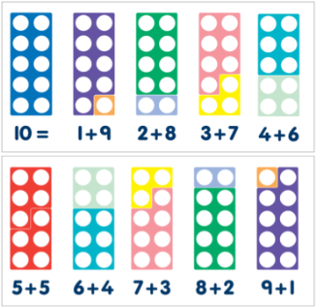 | ICT  Design an e-safety poster to keep people safe when using the internet.  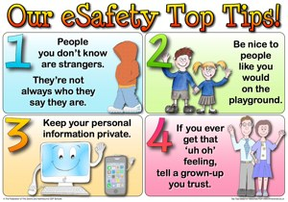 | Maths  Draw these given lengths using a ruler. Remember, your lines should be nice and straight. Write the measurement next to each line you draw.  - 2cm e) 6.5 cm  - 5cm f) 3.5cm  - 10cm g) 9.5cm  d) 4cm  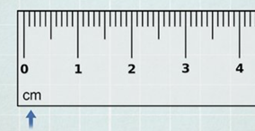
Science  Log onto Purple Mash and have a go at the materials quiz. See how many you can score correctly.  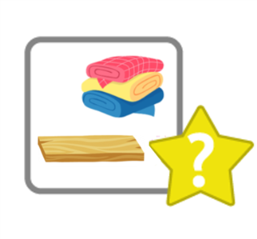 |   Holy Trinity CE Primary School  Homework grid for Year 2, Autumn 2  ~ Changes and Challenges  Choose any one box per week and complete the English, Maths or Topic homework.  Hand your homework book in every Wednesday for marking.  Thank you. | RE  Write about the Christmas story. Think about the journey to Bethlehem and the birth of Jesus. Try to think of different sentence openers.  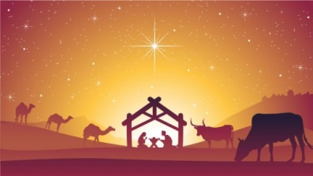
GPS
Write 10 noun phrases about animals e.g.
The spotty puppy.
A stripy badger.
She has a fluffy kitten.
Write an A over every adjectives and a N over each noun.
*Challenge- Try to make your sentences start differently.
RE- The Big Question:  What does God look like?  Write your answers/ ideas or you could even draw a picture. | Geography  Name the 7 continents and the 5 oceans.  Challenge yourself, can you write your own continents song?  The one we sing in class is available at: https://www.youtube.com/watch?v=K6DSMZ8b3LE
Art  Make an angel at home. It could be for a Christmas tree decoration, or on a Christmas card.  Bring it into school and we will take a photo and stick into your homework book for you.  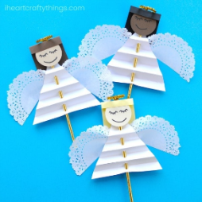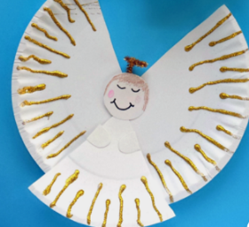 | English  Write a Christmas poem. It can be an acrostic poem, a rhyming poem or a silly poem- whatever you want!  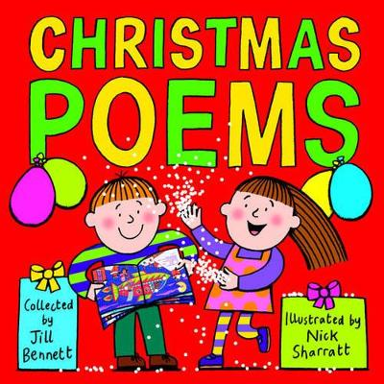 | Geography  Find out 5 facts about Alice Springs in Australia.  Write the facts in your neatest handwriting.  

