English- Traditional Tales with a Twist  We will continue to follow the Read, Write, Inc. scheme to learn our Set 1, Set 2 and Set 3 sounds. We will also have ‘Talk’ English lessons where we will be reading and writing about a variety of Fairy Tales and of course we will be talking about them, retelling them and acting them out. Please help your child by reading and enjoying as many fairy tales at home to support them in their learning.  Our home reading books are changed every Monday and Thursday. We ask that you read the home reading books 3 times to help increase your child’s fluency.  Our class library day is every Wednesday.  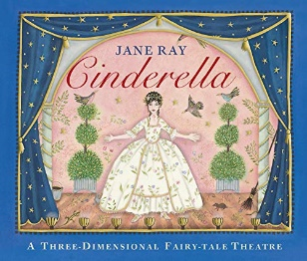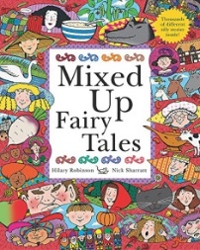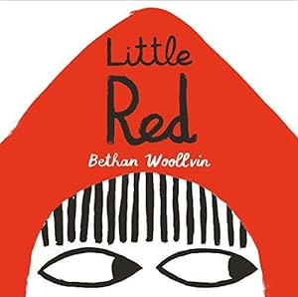 |  | Mathematics (Maths No Problem)  Chapter 4: Multiplication and division of 2, 5 and 10  This includes looking at different ways of sharing and grouping before investigating the links between multiplication and division and odd and even numbers.  Chapter 5: Length  This chapter helps children to get a better understanding of how to measure length (m and cm) and progress to measuring in real-life contexts.  Chapter 6: Mass  This chapter includes measuring mass in the contexts of kilograms and grams. They will learn to read a scale, compare weights and solve word problems relating to mass.

Science  In Science we will identify and compare the suitability of a variety of everyday materials, such as wood, metal, plastic, water, rock, paper and cardboard for particular uses. We will investigate if any materials can be changed by squashing, bending, twisting and stretching. Ultimately the children will learn that materials have different properties.  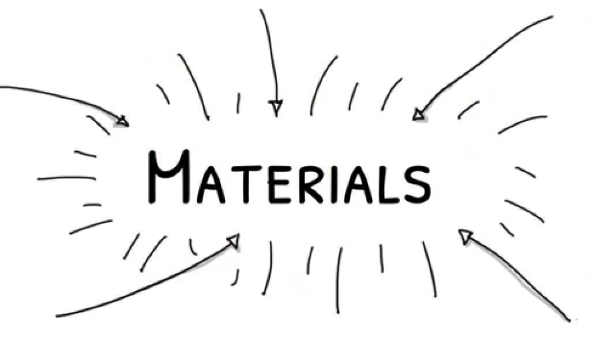 |  | Religious Education  Why do Christians believe the birth of Jesus was such good news?  In RE we develop the understanding that for Christians, Christmas is the celebration of the birth of Jesus, the Son of God and Savior of the world. We will be looking at how in the nativity story God sends good news through the angels.  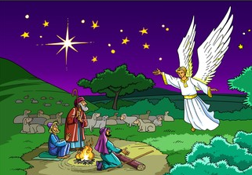 |  | Geography-  Alice Springs including the 7 continents and 5 oceans  Qu: Why do oceans matter?  We will be naming and locating the world’s seven continents and five oceans. We will then move on to learn about Alice Springs in the continent of Australia. We will be exploring why Alice Springs is geographically significant and comparing it to Burnley.  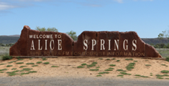

PE (taught by Mr. Little on a Tuesday and Friday)- FMS- Catching and Bouncing a Ball /Gymnastics Activities.

PSHE – National Anti-Bullying Week~ What is bullying? What to do about bullying and unsafe secrets.
We will also be discussing ‘Rights and Respect’.

Art & Design - We will be making Christmas cards and crafts.

DT- Sewing- Making pouches- The children will learn to sew a running stitch with regular-sized stitches and understand that both ends must be knotted. They will then decorate their pouch using the materials provided.

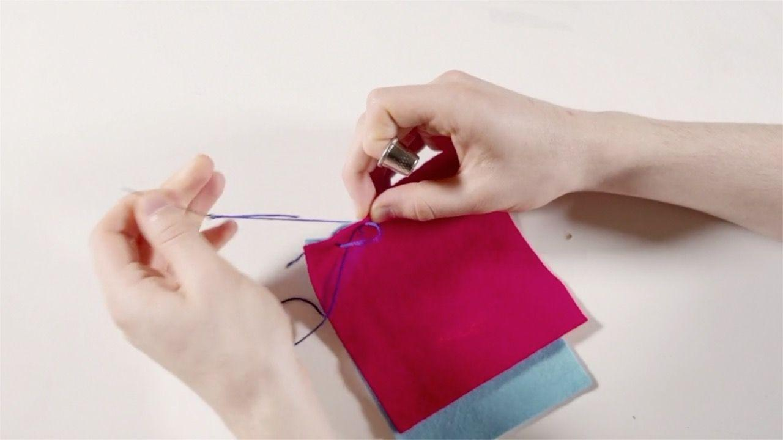

Music - Practising and rehearsing songs for EYFS and KS1 Nativity performance.

Computing – Online Safety. We will also be learning about ‘making music’.

Dates for your diary:
Odd Socks Day- Monday 9th November  Parents Evening- 12th November  Children in Need- Friday 20th November | Nativity- Tuesday 8th December  Christmas Jumper Day- Friday 10th December  Advent Service at St Matthew’s –Tuesday 15th December (1:30)  Christmas Disco- Tuesday 15th December  School closes- Thursday 17th December.

Vocabulary for Autumn 2
Please take some time to read these key words. They will help your child to understand what we will be learning this term.
running stitch  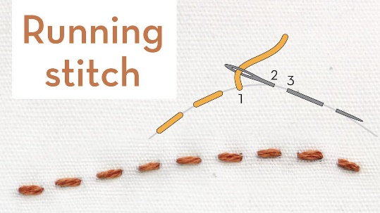 | needle and thread  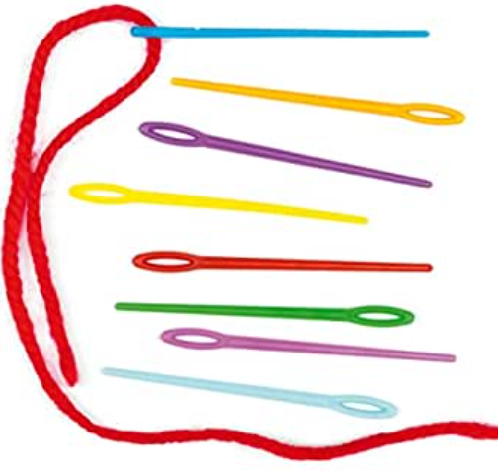 | template  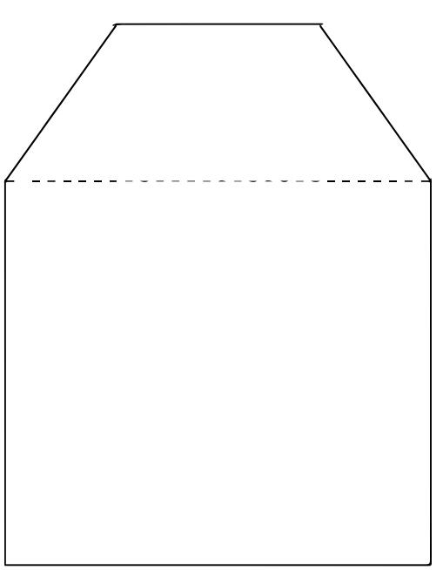
Alice Springs  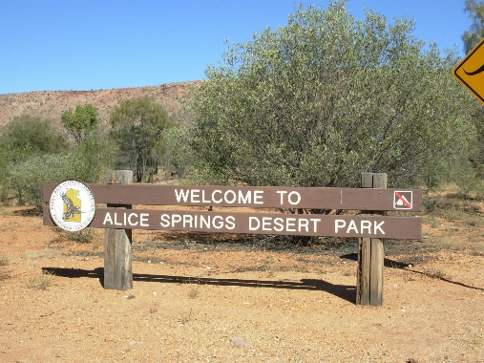 | Desert biome  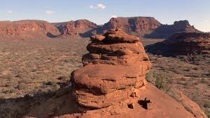 | Uluru/ Ayres Rock  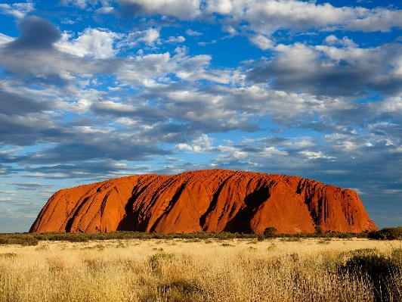
Length  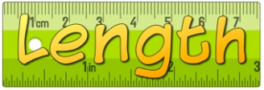 | Mass  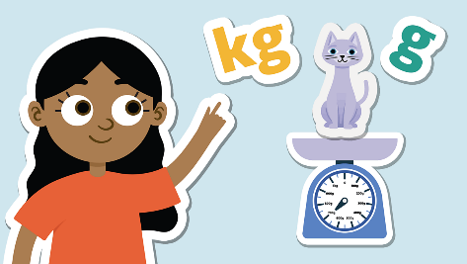 | E-Safety  

