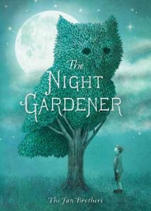  English- Folk Tales- The Greenling/ The Night Gardener.  Our English this term will focus on folk tales and how these are written. We will also look at character description and writing instructions. Our texts will be The Greenling by Levi Pinfold and The Night Gardener by the Fan Brothers.  Our grammar focus will be using inverted commas correctly and using commas correctly in complex sentences.  Our guided reading will focus on a range of extracts and using these to find out about inference- thinking about what the meaning is not just the literal words. |  |   Mathematics- MNP (Maths No Problem)  Through this half term we will be looking at:  - Multiplication and Division.  - Learning our 3, 4, and 8-times tables.  - Consolidating our 2. 5 and 10-times tables.  - Written methods for multiplication and division  - Length
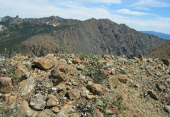  Science- Rocks and Soils  We will be learning about the different types of rocks and their properties. We will look at what fossils are and how they are formed, thinking about Mary Anning and her discovery.  We will also look at natural and human-made rocks and discuss their properties and uses. |  | Religious Education  Unit 3:1 cont’d  What is the role of a faith leader who has been called by God?  Exploring the stories of Old Testament Prophets. Interviewing Faith Leaders to explore their daily life.  Unit 3:2  Why do Christians believe that Jesus was Emmanuel. God with us?  Exploring the Nativity and looking for evidence that Jesus was the Son of God. |  | 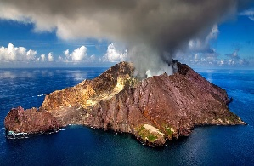  Geography- Volcanoes, Earthquakes and Tsunamis  We will explore what effect these natural occurrences have on human settlements. We will use atlases and maps to locate the Ring of Fire.  We will look at what volcanoes, earthquakes and tsunamis are and how they occur.  We will then use the information we have learnt to debate whether living near these natural occurrences is a good idea.
Design and Technology- Textiles
We will look at different stitches and methods of attaching decoration to make a small cushion

Spanish- Unit 2 Numbers and Ages.
Learning how to count to 20 and give our ages.
PSHE- Rights and Respect.
We use the SCARF PHSE materials to explore our rights and what it means to respect other viewpoints.
Computing – Email
Learning how to use emails safely to communicate with others. Send attachments and respond to emails.
Music- Charanga and Let’s Go Sing.
We will continue learning the songs ready for our performance in March as part of the Let’s Go Sing concerts.
PE
Mr Little will be teaching Handball and our other topic will be gymnastics.

Vocabulary for Autumn 2

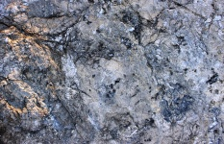  Marble  A hard, smooth metamorphic rock that starts off as limestone. | 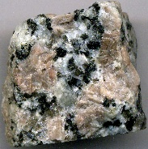  Granite  A hard, speckled rock made when hot, melted magma cools down very slowly underground. | 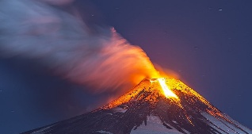  Volcano  An opening in the Earth’s crust that lets hot, melted rock, ash and gases escape from deep underground.
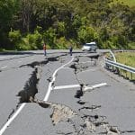  Earthquake  A sudden shaking, rolling or shock of the Earth’s surface caused by energy releasing deep underground. | 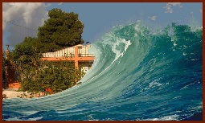  Tsunami  A series of giant powerful waves caused by a massive amount of water suddenly being displaced. | 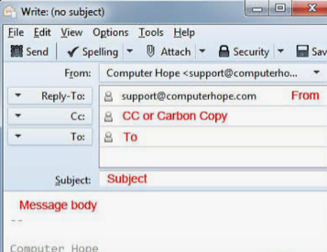  Email  A way to send and receive digital messages over the internet.
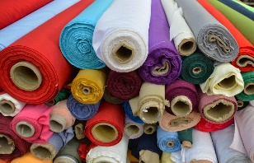  Textile  Any type of cloth made by weaving. | 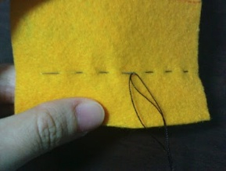  Running Stitch  A simple hand sewing stitch where the needle is passed up and down through the fabric. | 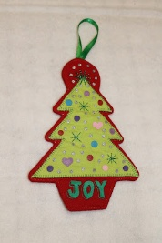  Applique  Cut out shapes or pictures that are sewn onto another piece of fabric to make a design.

