Maths- Multiplication and Division  We will be learning our 3, 4 and 8 times tables. Make sure you know them in and out of order and the related division facts.  Use TT Rockstars to help you practice. | RE Christian Value Perseverance.  Think of a Bible story where someone perseveres even when it is tough.  Write a short summary of the story. | Reading  Read your reading book at least 3 times per week. Bring your book in every day and we will change it on Monday, Wednesday and Friday.
Science Topic Rocks and Soils  Find 3 different rocks outside, draw the rocks and write two words to describe each one. E.g rough smooth etc. | Geography Volcanoes, Earthquakes and Tsunamis.  Draw and label a diagram of a volcano. | Geography Volcanoes, Earthquakes and Tsunamis.  Write an explanation of how an earthquake can cause a tsunami.
Science Topic Rocks and Soils  Have a good look around inside and outside your home. Make a list of all the human made and natural rocks you have in and around your home. |   Holy Trinity CE Primary School  Homework Grid Year 3  Autumn 2 | GPS  Using conjunctions and commas to make complex sentences.  Use the conjunctions: when, before, after, while, since, until, because, so, if and although in sentences using a comma to separate the two clauses.  e.g. Because it was raining, the children had to stay in.
Spelling

We have been learning about irregular past tense verbs. Write a list of as many verbs in the present tense that have irregular past tense and write them beside them.
e.g. see- saw
hear- heard
break- broke.

DT- Topic Textiles.
We will be using applique to add detail to our Christmas cushions. Draw a design you think you would like to sew onto your cushion. Don’t make it too hard for yourself!
RE- Topic Called by God

Research a modern day faith leader, The Archbishop of Canterbury or The Pope and see if you can find out how and why they felt called to God. Write a short explanation of what you find.

Handwriting

Log on to Letterjoin and start practising correct letter formation for all letters and simple joins.
English- The Night Gardener  Write a description of the town before the Night Gardener arrived.  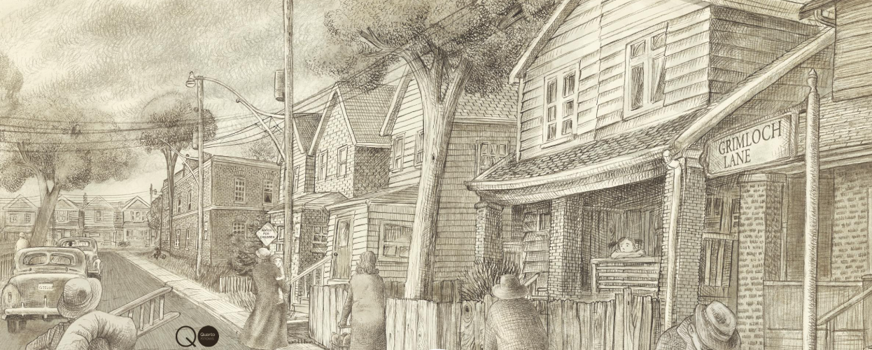 | Choose one activity box each week and complete the activity.  The activity boxes in red must be completed each term.  Reading and Maths should be completed each week.  Homework books should be handed in every Thursday morning. | RE Big Question  What does God look like?  Write your answer to this term’s Big Question in your books.

